**Simple Sales Data Visualization – Analyze and plot revenue, product demand, and seasonal sales trends.**

**Problem Statement**: Analyze and plot revenue,

product demand, and seasonal sales trends.

**Name**: Ashish

**Roll No**: [202401100400056]

Introduction

**Overview**: The goal of this project is to analyze and visualize sales data to gain insights into revenue trends, product demand, and seasonal sales trends.

**Problem Description**: The provided sales data will be analyzed to identify key trends and patterns. The data includes information on sales dates, revenue, and products.

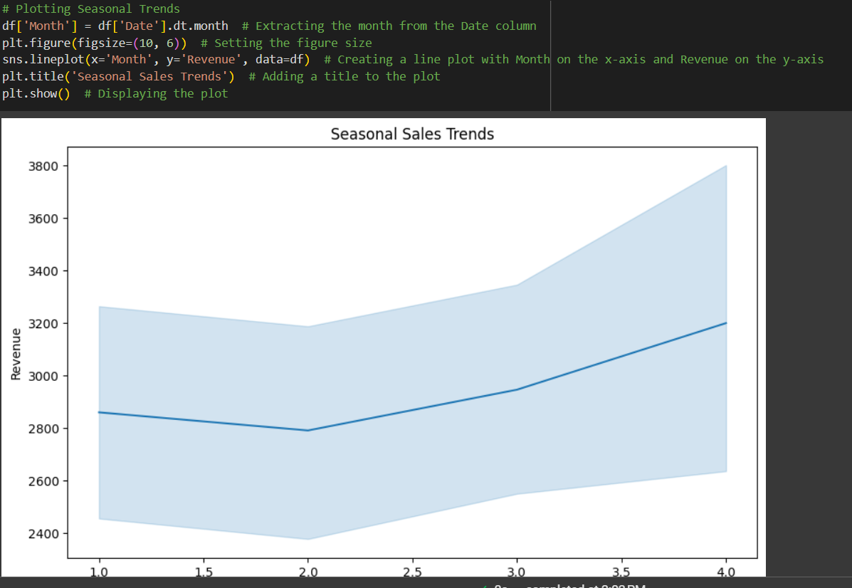

**Methodology**

**Approach**: The following steps were taken to solve the problem:

1. Data Collection: Loading the sales data from a CSV file.
2. Data Preprocessing: Cleaning and transforming the data for analysis.
3. Data Analysis: Analyzing revenue trends, product demand, and seasonal trends.
4. Data Visualization: Creating visualizations to represent the analysis results.

**Algorithms and Techniques**:

* **Libraries Used**:
  + pandas: For data manipulation.
  + numpy: For numerical operations.
  + matplotlib: For plotting.
  + seaborn: For enhanced visualizations.

CODE:

* import pandas as pd
* import numpy as np
* import matplotlib.pyplot as plt
* import seaborn as sns
* # Sample data
* data = {
* 'Date': pd.date_range(start='1/1/2021', periods=100),
* 'Revenue': np.random.randint(1000, 5000, size=100),
* 'Product': np.random.choice(['Product A', 'Product B', 'Product C'], size=100)
* }
* df = pd.DataFrame(data)
* # Revenue Over Time
* plt.figure(figsize=(10, 6))
* sns.lineplot(x='Date', y='Revenue', data=df)
* plt.title('Revenue Over Time')
* plt.show()
* # Product Demand
* plt.figure(figsize=(10, 6))
* sns.countplot(x='Product', data=df)
* plt.title('Product Demand')
* plt.show()
* # Seasonal Trends
* df['Month'] = df['Date'].dt.month
* plt.figure(figsize=(10, 6))
* sns.lineplot(x='Month', y='Revenue', data=df)
* plt.title('Seasonal Sales Trends')
* plt.show()